Reception/Year 1 Writing Curriculum
 | Autumn 1 | Autumn 2 | Spring 1 | Spring 2 | Summer 1 | Summer 2
Topic Links | Special and Unique Me | Special and Unique Me | Come Outside | Come Outside | Our Wonderful World | Our Wonderful World
Key Texts and Author of the half term | 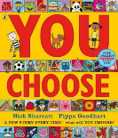  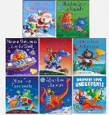  Claire Freeman | 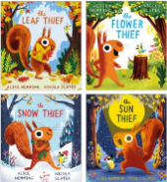  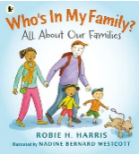  Alice Hemmings | 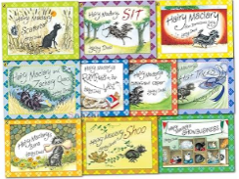  Lynley Dodd | 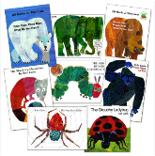  Eric Carle | 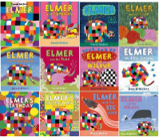  David McKee | 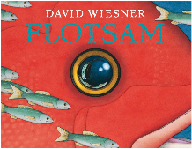  (Whole School text)  David Wiesner
Writing Outcomes | Make marks to represent writing. | Begin to form some recognisable letters.  Write dominant sounds in words. | Form some letters correctly.  Hear and write sounds in CVC words. | Write a caption or short phrase. | Write a short phrase or sentence. | Write a simple phrase or sentence which can be read by others.
Reception  Small Steps for grammar and punctuation | Continue to focus on and secure small steps from Nursery  - Create horizontal, vertical and diagonal lines and shapes (cross, square, triangle)  - Join in with letter formation rhymes e.g. during phonics  - Manipulate small objects and tools using one hand e.g. large tweezers, chunky beads, scissors  - Demonstrate bilateral coordination (using both sides of the body together) e.g. threading  - Use large arm movements with control e.g. air writing, making shapes with scarves, imitating actions  - Understand directional language e.g. around, diagonal, curl, straight, halfway, middle, top, bottom, across  - Make marks to represent their name  - Hear initial sounds in words and represent these in writing  - Talk about what their marks represent  - Write some letters in their name  - Begin to adjust pencil grip, holding pencil towards the tip | Continue to focus on and secure small steps from Autumn 1  - Begin to hear sounds in CVC words and represent dominant sounds in writing  - Begin to adjust pencil grip, holding pencil towards the tip  - Write some letters in their name | Continue to focus on and secure small steps from Autumn 2  - Hold a pencil using a tripod/effective grip with support (visual reminders, teacher support, phrase)  - Segment CVC words and write a letter for each sound (can be dictated)  - Write recognisable letters, some of which are correctly formed | Continue to focus on and secure small steps from Spring 1  - Use their phonic knowledge to write words/captions and simple phrases (can be dictated)  - Know that a sentence is a group of words joined together to communicate a thought or idea  - Orally complete a sentence using a sentence stem  - Hold a pencil using a tripod grip moving from the fingers and wrist  - Write recognisable letters, more of which are correctly formed  - Write their first name independently | Continue to focus on and secure small steps from Spring 2  - Form a sentence orally  - Write recognisable letters, most of which are correctly formed  - Hold a pencil using a tripod grip  - Begin to include tricky words in writing e.g. the, a, I  - Use their phonic knowledge (including special friends) to write words, phrases and short sentences (can be dictated) | Continue to focus on and secure small steps from Summer 1  - Correctly form most letters  - Begin to leave spaces between words  - Use their phonic knowledge to write words, phrases and short sentences (can be dictated)  - Write a phrase, caption or simple sentence (can be dictated) e.g. big red fish, the cat is fat  - Begin to write on a line/s  - Hold a pencil effectively using a tripod grip  - Follow ready to write routines independently  - Know that there are capital letters and that these are used at the beginning of a sentence and name  - Know that a sentence has a full stop at the end
Year 1  Small Steps for grammar and punctuation | - Children have at least one grapheme for all 44 phonemes.  - Correct letter formation for every letter.  - Learn to use letter names.  - Understand that ‘A sentence is a complete thought with a noun and a verb’.  - Understand that ‘A noun is a word for a person, object or a place’ (nouns POP).  - Understand that ‘A verb is an action word’ (doing).  - Know that the first letter of the first word in a sentence is always a capital letter (or uppercase).  - Know how to write capital letters.  - Know that a sentence always ends in a full stop.  Separate words with spaces. | - Children have a more precise choice of graphemes for their phonemes.  - Know sentence definitions by heart.  - Include plural words in dictated sentences and explain when to use ‘s’ or ‘es’  - Understand that ‘A sentence is a complete thought with a noun and a verb’.  - Understand that ‘A noun is a word for a person, object or a place’ (nouns POP).  - Understand that ‘A verb is an action word’ (doing). | - Write questions using question marks.  - Introduce terminology ‘An adjective is a describing word that adds information to a noun’.  - Use prefix ‘un-‘ to change the meaning of adjectives and verbs.  - Know how to write capital letters.  - Know that a sentence always ends in a full stop.  Separate words with spaces. | - Write exclamation sentences using exclamation marks.  - Include verbs ending in –ing with no spelling changes in dictated sentences (going, doing, flying).  Include verbs ending in –ed with no spelling changes in dictated sentences (slowed, helped, thanked). | - Use ‘and’ to form compound sentences from two simple sentences.  Include adjectives ending in ‘-er’ and ‘-est’ with no spelling changes (fast, slow, quick, small). | - Consolidate all the skills and knowledge and begin to sequence sentences into short narratives.  - Know that a simple sentence has a noun and a verb.  - Use capital letters and full stops.  - Use ‘and’ to join some sentences to make compound sentences.  - Use ‘and’ to form compound sentences from two simple sentences.
Key Vocabulary

Year 1/2 Writing Curriculum
 | Autumn 1 | Autumn 2 | Spring 1 | Spring 2 | Summer 1 | Summer 2
Author of the term and Key Texts | Emily Gravett  Astro Girl  Cave Baby  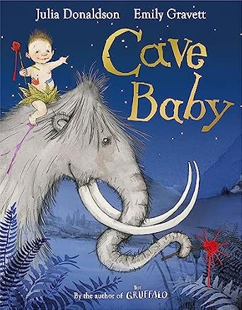 | Tom Percival  I Want My Hat Back  Dragon Post  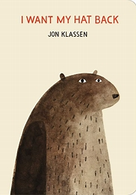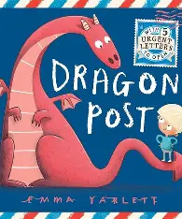 | Ben Miller | David Litchfield | Andy Shepherd | Whole school author focus - David Wiesner  Flotsam  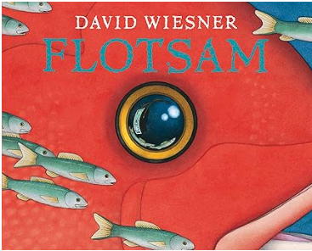
Year 1 outcomes | - Instructions  - Third person narrative  - Poetry (rhyme and repetition) | - Third person narrative  - Information text  - Instructions  - Poetry | - First person narrative  - Information text  - Poetry | - First person narrative  - Instructions (hand puppets) | - Third person narrative  - Information text  - Poetry | - First person narrative  - Recount (trip)
Year 1  Small Steps for grammar and punctuation | - Children have at least one grapheme for all 44 phonemes.  - Correct letter formation for every letter.  - Learn to use letter names.  - Understand that ‘A sentence is a complete thought with a noun and a verb’.  - Understand that ‘A noun is a word for a person, object or a place’ (nouns POP).  - Understand that ‘A verb is an action word’ (doing).  - Know that the first letter of the first word in a sentence is always a capital letter (or uppercase).  - Know how to write capital letters.  - Know that a sentence always ends in a full stop.  - Separate words with spaces. | - Write questions using question marks.  - Introduce terminology ‘An adjective is a describing word that adds information to a noun’.  - Use prefix ‘un-‘ to change the meaning of adjectives and verbs.  - Know how to write capital letters.  - Know that a sentence always ends in a full stop.  - Separate words with spaces. | - Children have a more precise choice of graphemes for their phonemes.  - Know sentence definitions by heart.  - Include plural words in dictated sentences and explain when to use ‘s’ or ‘es’  - Understand that ‘A sentence is a complete thought with a noun and a verb’.  - Understand that ‘A noun is a word for a person, object or a place’ (nouns POP).  - Understand that ‘A verb is an action word’ (doing). | - Write exclamation sentences using exclamation marks.  - Include verbs ending in –ing with no spelling changes in dictated sentences (going, doing, flying).  - Include verbs ending in –ed with no spelling changes in dictated sentences (slowed, helped, thanked). | - Use ‘and’ to form compound sentences from two simple sentences.  - Include adjectives ending in ‘-er’ and ‘-est’ with no spelling changes (fast, slow, quick, small). | - Consolidate all the skills and knowledge and begin to sequence sentences into short narratives.  - Know that a simple sentence has a noun and a verb.  - Use capital letters and full stops.  - Use ‘and’ to join some sentences to make compound sentences.  - Use ‘and’ to form compound sentences from two simple sentences.
Year 2 Key texts | Only one You  Have you filled a bucket  Vlad and the Great fire of London  Fire Engines | Baba Yaga and Hansel and Gretel  Diary of a Wombat  A journey Home | Wolves  Stories about the wild: The Fox, The Tine Man and The Whale Song | The owl and the pussy cat  The bear and the Piano | Dragon  The Dragon Machine | Walk in London  House held up by trees
Year 2 outcomes | Diaries and postcards (fiction based)  Information text | Traditional Tales - Narrative character description  Instructions  Persuasive writing | Narrative  Reports | Rhyming poems  Narrative | Reports  Narrative descriptions  Poetry | Tour guides  Reports  Narrative
Year 2  Small Steps for grammar and punctuation | - Spend the first few weeks recapping the main Y1 sentence writing small steps.  - A simple sentence has a noun, a verb, a capital letter at the start and a full stop at the end.  - We can extend simple sentences by expanding nouns into noun phrases.  - A noun phrase is a group of words that work together as a well-described noun.  - Simple past tense verbs often end in ‘-ed’.  - A sentence can do four different jobs.  - A statement sentence tells you something that is a fact.  - A question sentence asks something that requires an answer.  - An exclamation sentence expresses a strong emotion.  - A command sentence tells you what to do and begins with a bossy (imperative) verb.  - Use ‘and’ to join some sentences to make compound sentences (Y1). | - Stories are often written in the past tense which shows it has already happened.  - We can extend simple sentences by expanding nouns into noun phrases.  - A compound sentence is two simple sentences joined by a co-ordinating conjunction, such as ‘and’, ‘but’ or ‘so’.  - Introduce terminology ‘A compound sentence is two simple sentences joined by a co-ordinating conjunction’  - A sentence can do four different jobs.  - A statement sentence tells you something that is a fact.  - A question sentence asks something that requires an answer.  - An exclamation sentence expresses a strong emotion.  - A command sentence tells you what to do and begins with a bossy (imperative) verb.  - Use ‘and’ to join some sentences to make compound sentences (Y1). | - A clause is a part of a sentence: it is a group of words which always includes a verb.  - Introduce terminology ‘A clause is a part of a sentence that always has a verb’  - A complex sentence has a main clause and a subordinate clause.  - Introduce terminology ‘A complex sentence has a main clause and a subordinating clause’  - Most complex sentences have a subordinating conjunction, such as ‘when’, ‘if’, ‘because’ or ‘that’.  - Stories and recounts can be written in the first person (I, me, my) when the writer pretends to be the character or in the third person when the writer tells the story about someone else. | - We can add information to a verb using when-adverbs and how-adverbs.  - A when-adverb tells you when the verb is happening, such as ‘next’, ‘then’, ‘after’, ‘before’.  - A how-adverb tells you the way the verb is happening, such as ‘suddenly’, ‘slowly’, ‘luckily’, ‘sadly’.  - Nouns can be formed by adding the suffixes -ness and -er  - Introduce terminology ‘A complex sentence has a main clause and a subordinating clause’ | - There are two types of past tense verb.  - Simple past tense verbs end in ‘-ed’.  - Past progressive verbs use ‘was’ and end in ‘-ing’ (such as ‘was jumping’).  - Writers use the past progressive verb form to make their readers feel like they are there in the story.  - We use commas to separate a list of words which makes it easier to read.  - Adjectives can be formed by adding the suffixes -ful and -less | - Apostrophes are used to show who a noun belongs to.  - Apostrophes are used to show a contracted (shortened) version of a word, such as ‘can’t’ or ‘won’t’.  - When we write in the present tense, we can use the simple present (he jumps) or the present progressive (he is jumping).  - The present progressive makes it clearer that something is happening right now.  - Adjectives can be changed using the suffixes -er and -est  - Adjectives can be changed into adverbs using the suffix -ly
Key Vocabulary | Noun  Verb  Noun phrase  Past tense  Command  Statement  Question  exclamation | Noun phrase  Co-ordinating conjunction  Compound sentence  Command  Statement  Question  Exclamation | Verb  Complex sentence  Subordinate clause  Main clause  Subordinating conjunction  First person  First person | Adverb  Suffixes  Complex sentence  Subordinate clause  Main clause  Subordinating conjunction | Past tense verbs  Past progressive verbs  Commas  adjectives | Apostrophes  Present progressive  Adjectives  adverbs

Year 3/4 Writing Curriculum
 | Autumn 1 | Autumn 2 | Spring 1 | Spring 2 | Summer 1 | Summer 2
Topic Links | Friendship | History – Stone Age to Iron Age Britain  Science Magnets | Geography- uk cities | Science – Plants Living things | Christina Balit  (Romans -History) | Design and Technology - Castles
Key Texts | The BFG  Roald Dahl  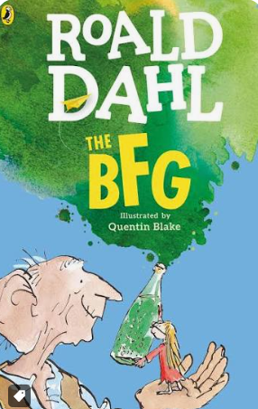 | Stone Age Boy  Satoshi Kitamura   | Mr Penguin and the Lost Treasure Alex T Smith   | I am the seed that grew the tree – Variety of poets  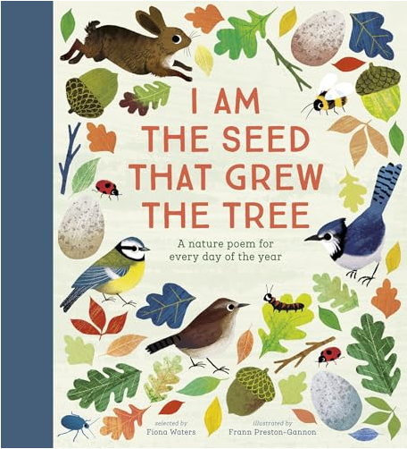 | Escape from Pompeii  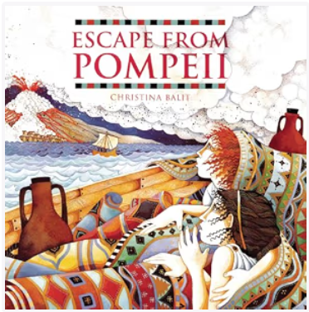 | Hilaire Belloc & Mini Grey  Jim a Cautionary Tale  Whole school Author - David Wiesner  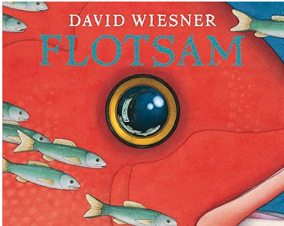
Writing Outcomes | - Narrative with a character focus  - Narrative with a setting focus | - Information Text – Stone Age  - Instructions  Instructions for a magnetic game | - Narrative with a character focus – mystery story  Persuasive text – Geography UK cities | - Narrative with a setting focus – using poems to inspire  Information text  Science - plants | Narrative with a setting and character focus  Diaries  Newspaper/recount History Romans | Fairy tales/traditional stories  Assessed Writing 1  Tale with a moral  Assessment 2 whole school project
Year 3  Small Steps for grammar and punctuation | - Spend the first half-term of Y3 ensuring that all children understand the sentence writing small steps from KS1 and can use these ideas with fluency and automaticity. You may like to consider introducing no new content to ensure these important component skills are mastered.  - There are three main types of sentence: simple sentences, compound sentences and complex sentences.  - Simple sentences are made of one clause which has a noun and a verb.  - Compound sentences have two clauses, joining two simple sentences with a coordinating conjunction – ‘and’, ‘but’ or ‘so’  - A complex sentence has a main clause and a subordinate clause.  - Complex sentences use commas to separate multiple clauses.  - The nouns and verbs in any clause can be extended using adverbs.  - In non-fiction writing, we use headings and sub-headings to introduce what a section of the text is all about. | - We use paragraphs to group sentences that are about the same topic or idea.  - We usually show the separation between paragraphs by leaving a blank line to make it easier for the reader.  - Where-adverbs give more information about where the verb is happening (under, below, behind).  - Where-adverbs are also called ‘prepositions’  - Stories and recounts can be written in the first person (I, me, my) when the writer pretends to be the character or in the third person when the writer tells the story about someone else (Y2)  - A when-adverb tells you when the verb is happening, such as ‘next’, ‘then’, ‘after’, ‘before’.(Y2)  - A how-adverb tells you the way the verb is happening, such as ‘suddenly’, ‘slowly’, ‘luckily’, ‘sadly’. (Y2)  - Apostrophes are used to show who a noun belongs to. (Y2)  - Apostrophes are used to show a contracted (shortened) version of a word, such as ‘can’t’ or ‘won’t’ (Y2)  - We use commas to separate a list of words which makes it easier to read. (Y2)  - A command sentence tells you what to do and begins with a bossy (imperative) verb. (Y2) | - We use inverted commas to show when a character is speaking in our writing.  - An inverted comma goes before the character begins to speak and at the end of what they say.  - When a new character starts speaking, we start a new line.  - We can extend simple sentences by expanding nouns into noun phrases (Y2)  - A compound sentence is two simple sentences joined by a co-ordinating conjunction, such as ‘and’, ‘but’ or ‘so’. (Y2)  - When we are writing in the past tense, we most often use the simple past (she jumped / she went outside). | - Nouns can be formed with different prefixes e.g. super-, anti-, auto-  - Know when to use ‘a’ or ‘an’ for a word beginning with a consonant or a vowel  - A complex sentence has a main clause and a subordinate clause.  - Complex sentences use commas to separate multiple clauses  - Where-adverbs give more information about where the verb is happening (under, below, behind).  - Where-adverbs are also called ‘prepositions’ | - When we are writing in the past tense, we most often use the simple past (she jumped / she went outside).  - We use the present perfect verb form to say that something has only just happened.  - To use the present perfect verb form, we use ‘has’ and then a simple past tense verb (has jumped / has gone outside).  - Apostrophes are used to show a contracted (shortened) version of a word, such as ‘can’t’ or ‘won’t’ (Y2)  - In non-fiction writing, we use headings and sub-headings to introduce what a section of the text is all about.  - A complex sentence has a main clause and a subordinate clause | Consolidation of all objectives taught so far
Year 4  Small Steps for grammar and punctuation | - Spend the first few weeks cementing the main sentence writing small steps already taught.  - There are three main types of sentence: simple sentences, compound sentences and complex sentences.  - Phrases are parts of a sentence without a verb.  - Clauses are parts of a sentence which include a verb.  - We can describe nouns carefully by turning them into noun phrases using adjectives and other words.  - We can add description to our verbs using when-adverbs, where-adverbs and how-adverbs.  - We use paragraphs to group sentences that are about the same topic or idea | - We use inverted commas to show when a character is speaking in our writing.  - We always use a piece of punctuation before the closing inverted comma when punctuating direct speech.  - We use a comma, an exclamation mark or a question mark at the end of the speech when the inverted commas are followed by a verb e.g. “You’re right!” exclaimed Max.  - We only use a full stop at the end of the speech before the closing inverted commas if it is the end of the sentence.  - We always use a comma after the reporting clause before the opening inverted commas e.g. Max exclaimed, “You’re right!”  - Pronouns are words used to replace proper nouns, such as ‘it’, ‘she’, ‘he’, ‘they’.  - We use pronouns to replace nouns, so our writing doesn’t sound repetitive.  - Know the difference between plural -s and possessive -’s  - A command sentence tells you what to do and begins with a bossy (imperative) verb. (Y2) | - Adverbial phrases are phrases that act like an adverb (under the stairs/with my heart in my mouth).  - Adverbs and adverbial phrases can be moved around a sentence for different impact.  - When we use adverbs and adverbial phrases at the beginning of a sentence, we call it a ‘fronted adverbial’.  - We always use a comma after a fronted adverbial to separate it from the rest of the sentence  - We use inverted commas to show when a character is speaking in our writing.  - We always use a piece of punctuation before the closing inverted comma when punctuating direct speech.  - We use a comma, an exclamation mark or a question mark at the end of the speech when the inverted commas are followed by a verb e.g. “You’re right!” exclaimed Max.  - We only use a full stop at the end of the speech before the closing inverted commas if it is the end of the sentence.  Stories and recounts can be written in the first person (I, me, my) when the writer pretends to be the character or in the third person when the writer tells the story about someone else (Y2) | - Pronouns are words used to replace proper nouns, such as ‘it’, ‘she’, ‘he’, ‘they’.  - We use pronouns to replace nouns, so our writing doesn’t sound repetitive.  Know the difference between plural -s and possessive -’s | - We use inverted commas to show when a character is speaking in our writing.  - We always use a piece of punctuation before the closing inverted comma when punctuating direct speech.  - We use a comma, an exclamation mark or a question mark at the end of the speech when the inverted commas are followed by a verb e.g. “You’re right!” exclaimed Max.  - We only use a full stop at the end of the speech before the closing inverted commas if it is the end of the sentence.  - We always use a comma after the reporting clause before the opening inverted commas e.g. Max exclaimed, “You’re right!”  - In non-fiction writing, we use headings and sub-headings to introduce what a section of the text is all about. (Y3)  Apostrophes are used to mark plural possession (knowing the difference between singular and plural) e.g. the girl's room, the girls' room. | - Consolidation of all objectives taught so far  - When we write in the present tense, we can use the simple present (he jumps) or the present progressive (he is jumping).  - The present progressive makes it clearer that something is happening right now (Y2)  - We use the present perfect verb form to say that something has only just happened (Y3)
Key Vocabulary
Reading Focus | - Retrieval  - Summarising  - Inference | - Prediction  - Comparison  - Inference | - Retrieval  - Summarising  - Inference | - Prediction  - Comparison  - Inference | - Retrieval  - Summarising  - Inference | - Prediction  - Comparison  - Inference

Year 5/6 Writing Curriculum
 | Autumn 1 | Autumn 2 | Spring 1 | Spring 2 | Summer 1 | Summer 2
Topic Links | Ancient Egypt | Ancient Egypt | Earth & Space |  |  | The Mayas
Key Texts |  | 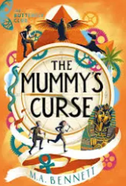 | 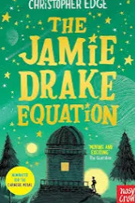 |  | 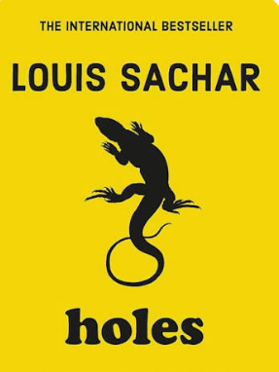 | 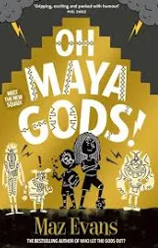
Writing Outcomes | - Setting description  - Diary | - Myths  - Instructions | - Information Text  - Poetry | - Narrative with dialogue | - Character Description  - Letter | - Narrative that describes character, setting, atmosphere and plot  - Persuasion Text
Year 5  Small Steps for grammar and punctuation | - Spend the first few weeks cementing the main sentence writing small steps already taught.  - There are three main types of sentence: simple sentences, compound sentences and complex sentences.  - Phrases are parts of a sentence without a verb.  - Clauses are parts of a sentence which include a verb.  - We can describe nouns carefully by turning them into noun phrases using adjectives and other words.  - We can add description to our verbs using when-adverbs, where-adverbs and how-adverbs.  - We use paragraphs to group sentences that are about the same topic or idea  - When we use adverbs and adverbial phrases at the beginning of a sentence, we call it a ‘fronted adverbial’.  A command sentence tells you what to do and begins with a bossy (imperative) verb. (Y2) | - We use inverted commas to show when a character is speaking in our writing.  - We always use a piece of punctuation before the closing inverted comma when punctuating direct speech.  - We use a comma, an exclamation mark or a question mark at the end of the speech when the inverted commas are followed by a verb e.g. “You’re right!” exclaimed Max.  - We only use a full stop at the end of the speech before the closing inverted commas if it is the end of the sentence.  - We always use a comma after the reporting clause before the opening inverted commas e.g. Max exclaimed, “You’re right!”  - Stories and recounts can be written in the first person (I, me, my) when the writer pretends to be the character or in the third person when the writer tells the story about someone else (Y2)  - Pronouns are words used to replace proper nouns, such as ‘it’, ‘she’, ‘he’, ‘they’.  - We use pronouns to replace nouns, so our writing doesn’t sound repetitive.  Know the difference between plural -s and possessive -’s | - Adverbial phrases are phrases that act like an adverb (under the stairs/with my heart in my mouth).  - In non-fiction writing, we use headings and sub-headings to introduce what a section of the text is all about. (Y3)  - Adverbs and adverbial phrases can be moved around a sentence for different impact.  - When we use adverbs and adverbial phrases at the beginning of a sentence, we call it a ‘fronted adverbial’.  - We always use a comma after a fronted adverbial to separate it from the rest of the sentence  - We use inverted commas to show when a character is speaking in our writing.  - We always use a piece of punctuation before the closing inverted comma when punctuating direct speech.  - We use a comma, an exclamation mark or a question mark at the end of the speech when the inverted commas are followed by a verb e.g. “You’re right!” exclaimed Max.  - We only use a full stop at the end of the speech before the closing inverted commas if it is the end of the sentence. | - We use inverted commas to show when a character is speaking in our writing.  - We always use a piece of punctuation before the closing inverted comma when punctuating direct speech.  - We use a comma, an exclamation mark or a question mark at the end of the speech when the inverted commas are followed by a verb e.g. “You’re right!” exclaimed Max.  - We only use a full stop at the end of the speech before the closing inverted commas if it is the end of the sentence.  - We always use a comma after the reporting clause before the opening inverted commas e.g. Max exclaimed, “You’re right!”  Apostrophes are used to mark plural possession (knowing the difference between singular and plural) e.g. the girl's room, the girls' room. | - When we use adverbs and adverbial phrases at the beginning of a sentence, we call it a ‘fronted adverbial’. | - Consolidation of all objectives taught so far  - When we write in the present tense, we can use the simple present (he jumps) or the present progressive (he is jumping).  - The present progressive makes it clearer that something is happening right now (Y2)  - We use the present perfect verb form to say that something has only just happened (Y3)
Year 6  Small Steps for grammar and punctuation | - Spend the first few weeks cementing the main sentence writing small steps already taught.  - There are three main types of sentence: simple sentences, compound sentences and complex sentences.  - Phrases are parts of a sentence without a verb.  - Clauses are parts of a sentence which include a verb.  - We can describe nouns carefully by turning them into noun phrases using adjectives and other words.  - We can add description to our verbs using when-adverbs, where-adverbs and how-adverbs.  - We use paragraphs to group sentences that are about the same topic or idea  - A command sentence tells you what to do and begins with a bossy (imperative) verb. (Y2) | - We use inverted commas to show when a character is speaking in our writing.  - We always use a piece of punctuation before the closing inverted comma when punctuating direct speech.  - We use a comma, an exclamation mark or a question mark at the end of the speech when the inverted commas are followed by a verb e.g. “You’re right!” exclaimed Max.  - We only use a full stop at the end of the speech before the closing inverted commas if it is the end of the sentence.  - We always use a comma after the reporting clause before the opening inverted commas e.g. Max exclaimed, “You’re right!”  - Stories and recounts can be written in the first person (I, me, my) when the writer pretends to be the character or in the third person when the writer tells the story about someone else (Y2)  - Pronouns are words used to replace proper nouns, such as ‘it’, ‘she’, ‘he’, ‘they’.  - We use pronouns to replace nouns, so our writing doesn’t sound repetitive.  - Know the difference between plural -s and possessive -’s | - Adverbial phrases are phrases that act like an adverb (under the stairs/with my heart in my mouth).  - Adverbs and adverbial phrases can be moved around a sentence for different impact.  - When we use adverbs and adverbial phrases at the beginning of a sentence, we call it a ‘fronted adverbial’.  - We always use a comma after a fronted adverbial to separate it from the rest of the sentence  - We use inverted commas to show when a character is speaking in our writing.  - We always use a piece of punctuation before the closing inverted comma when punctuating direct speech.  - We use a comma, an exclamation mark or a question mark at the end of the speech when the inverted commas are followed by a verb e.g. “You’re right!” exclaimed Max.  - We only use a full stop at the end of the speech before the closing inverted commas if it is the end of the sentence. | - In non-fiction writing, we use headings and sub-headings to introduce what a section of the text is all about. (Y3)  - When we use adverbs and adverbial phrases at the beginning of a sentence, we call it a ‘fronted adverbial’. | - We use inverted commas to show when a character is speaking in our writing.  - We always use a piece of punctuation before the closing inverted comma when punctuating direct speech.  - We use a comma, an exclamation mark or a question mark at the end of the speech when the inverted commas are followed by a verb e.g. “You’re right!” exclaimed Max.  - We only use a full stop at the end of the speech before the closing inverted commas if it is the end of the sentence.  - We always use a comma after the reporting clause before the opening inverted commas e.g. Max exclaimed, “You’re right!”  - Apostrophes are used to mark plural possession (knowing the difference between singular and plural) e.g. the girl's room, the girls' room. | - Consolidation of all objectives taught so far  - When we write in the present tense, we can use the simple present (he jumps) or the present progressive (he is jumping) Y2.  - The present progressive makes it clearer that something is happening right now (Y2)  - We use the present perfect verb form to say that something has only just happened (Y3)
Key Vocabulary
Reading Focus | - Retrieval  - Summarising  - Inference | - Prediction  - Comparison  - Inference | - Retrieval  - Summarising  - Inference | - Prediction  - Comparison  - Inference | - Retrieval  - Summarising  - Inference | - Prediction  - Comparison  - Inference

